Assignment-4
1) List the number of employees and average salary for employees in department 20.
2) List name, salary and PF amount of all employees. (PF is calculated as 10% of basic salary)
3) List names of employees who are more than 2 years old in the company.
4) List the employee details in the ascending order of their basic salary.
5) List the employee name and hire date in the descending order of the hire date.
6) List employee name, salary, PF, HRA, DA and gross; order the results in the ascending order of gross. HRA is 50% of the salary and DA is 30% of the salary.
7) List the department numbers and number of employees in each department.

8) List the department number and total salary payable in each department.
9) List the jobs and number of employees in each job. The result should be in the descending order of the number of employees.
10) List the total salary, maximum and minimum salary and average salary of the employees’ job wise.
11) List the total salary, maximum and minimum salary and average salary

ANSWER
List the number of employees and average salary for employees in department 20.
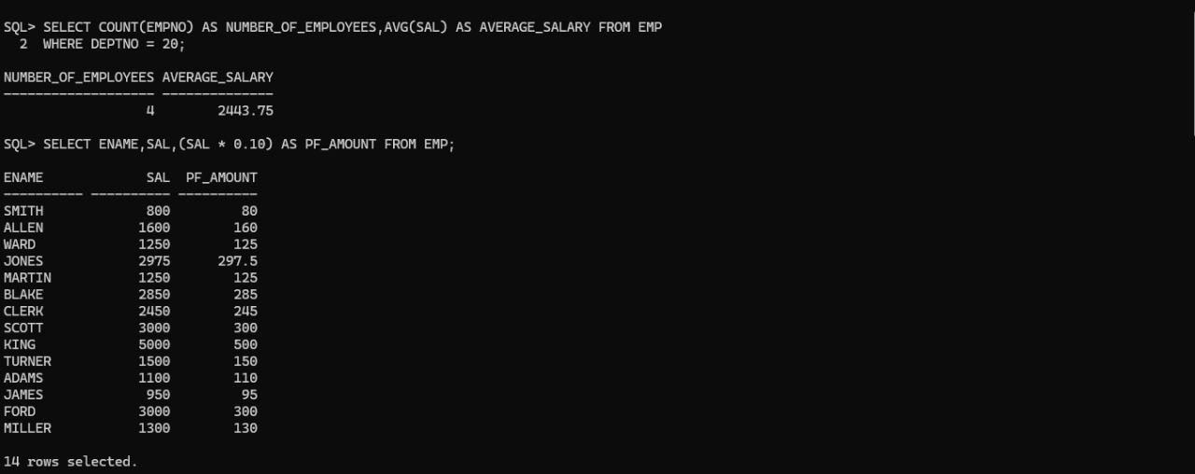

List name, salary and PF amount of all employees. (PF is calculated as 10% of basic salary)

List names of employees who are more than 2 years old in the company.

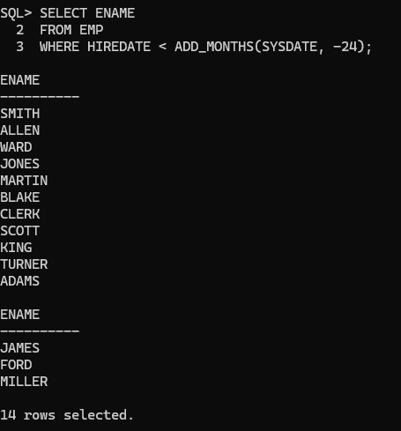

List the employee details in the ascending order of their basic salary.

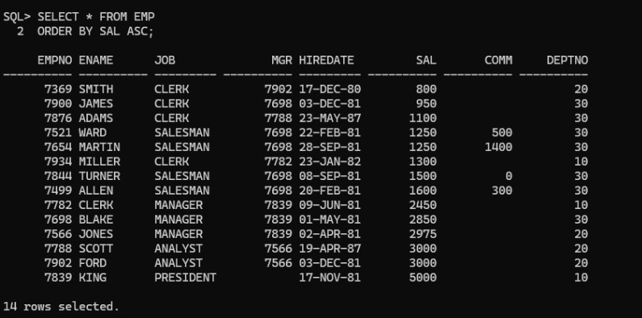

List the employee name and hire date in the descending order of the hire date.

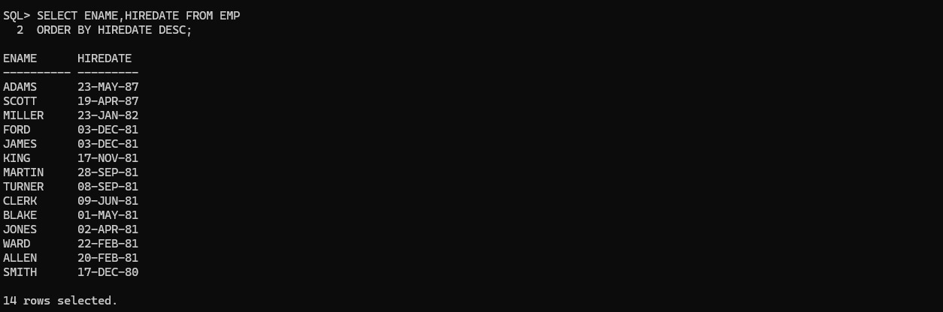
List employee name, salary, PF, HRA, DA and gross; order the results in the ascending order of gross. HRA is 50% of the salary and DA is 30% of the salary.

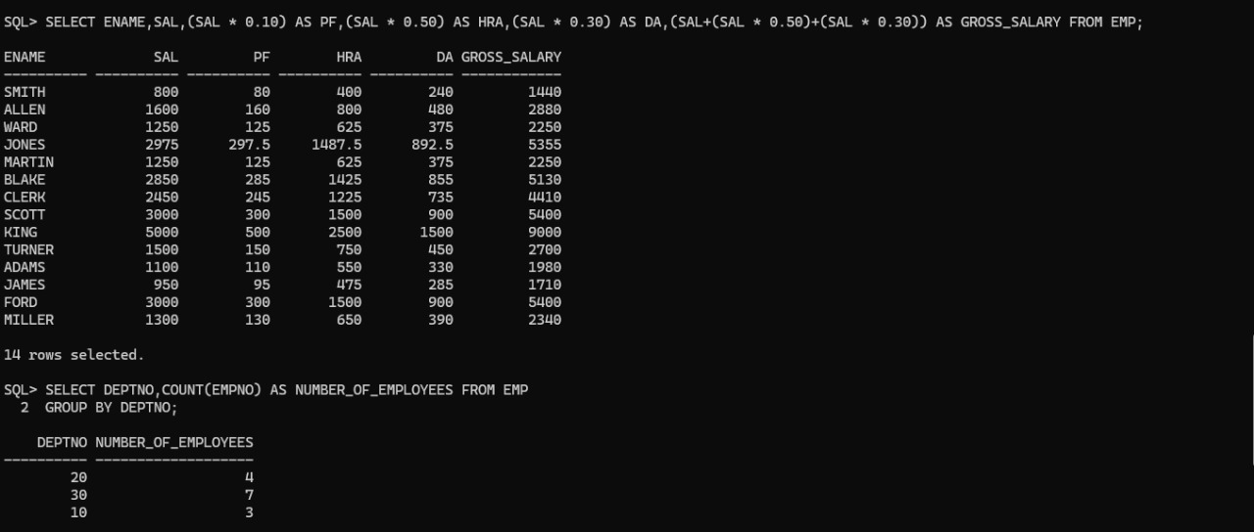

List the department numbers and number of employees in each department.

List the department number and total salary payable in each department.

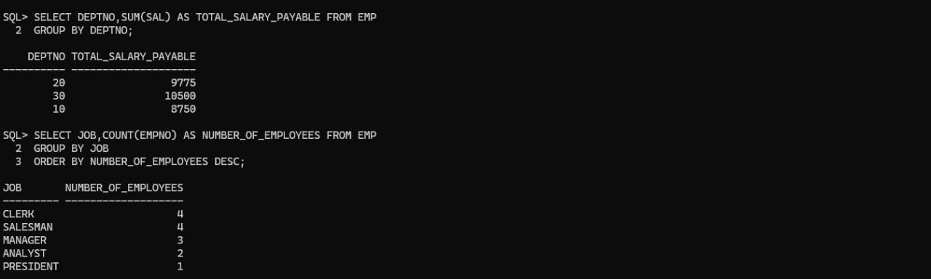

List the jobs and number of employees in each job. The result should be in the descending order of the number of employees.

List the total salary, maximum and minimum salary and average salary of the employees’ job wise.
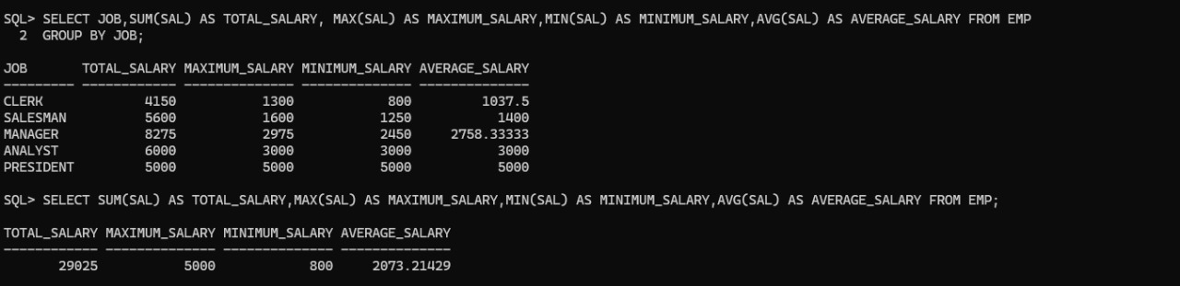

List the total salary, maximum and minimum salary and average salary

